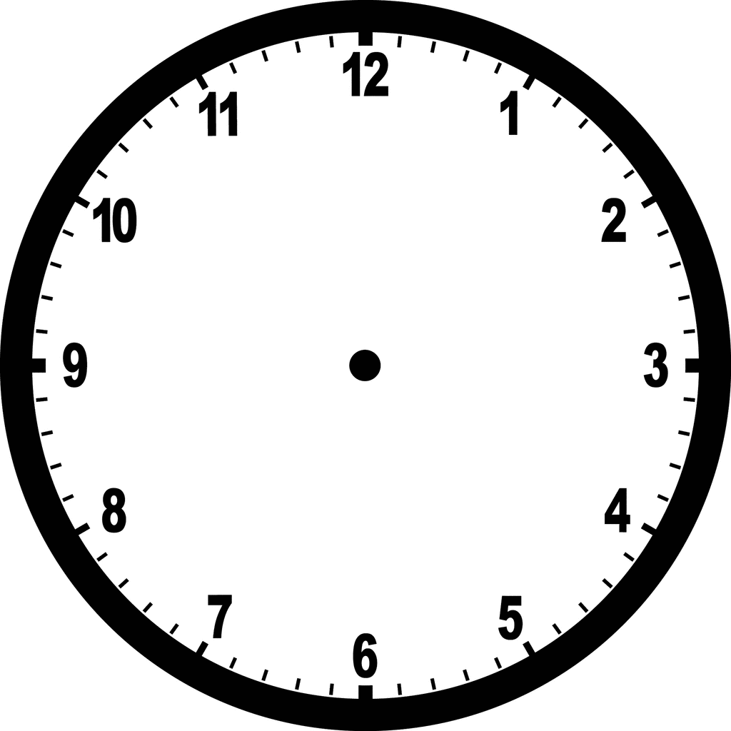  O’Clock | The Analogue Clock uses hands to tell the time.  The Minute Hand is long.  The Hour Hand is short.  From 12 – 6, is Past the hour.  From 6 – 12, is To the next hour. | Quarter Past
Half Past | To  Past | Quarter to

5 past | 25 past | 20 to
10 past | Use the numbers on the face of the clock to tell the time at  5 minute intervals | 10 to
20 past | 25 to | 5 to

3 minutes past | 27 minutes past | 9 minutes to
8 minutes past | Use the lines between the numbers on the face of the clock to tell the time at  1 minute intervals | 13 minutes to
19 minutes past | 2 minutes to | 26 minutes to

