The Butterfly Heart

A Study Guide

Ms Mackey’s 5th Class

St John’s Senior School, Kilkenny Ireland 2012

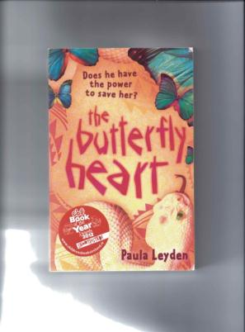
www.thebutterflyheart.net

CONTENTS
Section Page

- Introduction 3
- Questions on the book per Chapter 4
- Armadillo Fact Sheet 15
- The Puff Adder 17
- The Life Cycle of the Tapeworm 18
- Definition of HIV/AIDS 19
- Hookworm images 20
- The Baobab Tree 21
- Some useful Words in chiBemba 22
- Cloze Procedure 23
- The Bird and the Badger Game 25
- Say No to Child Marriage Images 26
- Bemba Bingo! 27
- Wordsearch & Cloze 28
- Last Will and Testament 29
- Madillo’s School Report 30
- Character Portraits 31
- Things you don’t know about Paula Leyden 35
- Sentence Search 37
- Book Review 43

Introduction
These teaching notes were prepared and taught by Orla Mackey a teacher at St. John’s School in Kilkenny, Ireland. The book was read by a Fifth Class (average age 10-11).
They read the book as part of a One Book Project that the school does each year. Each child got a copy of the book and there were books available for the parents to borrow as well.
In addition to what is contained in the notes, the class also produced a lot of art work inspired by the book and did a class of African drumming which seemed to go down very well.

The questions in the first section were sometimes dealt with in written work, other times orally. They were projected onto the whiteboard. In addition to this Ms. Mackey set up an email address through which the class could send me comments and questions as a class. I then put up samples of their work on my website so they could interact in that way as well. These can be seen at http://thebutterflyheart.net/st-johns-school-kilkenny/ The school is in my area so I did a couple of author visits to all the classes doing the book – there were a hundred children in total who studied at simultaneously. And all the teachers concerned did great work with them.

Orla herself has been teaching at St. John’s for the past five years, after having studied English Literature at Trinity, A Higher Diploma in Secondary School Teaching and then the Hibernia Higher Diploma in Primary Teaching.

She has travelled widely and has been to Africa herself. In her own words ‘I went to Tanzania, Malawi, Zambia, Mozambique and South Africa. I met some of the most beautiful people you could ever hope to encounter and made memories that will stay with me forever. I still look forward to the day when I will visit Africa again.’

I also asked her about her favourite part of being a teacher, ‘One of my favourite things about teaching is learning. I love the fact that every time I tackle a particular theme or topic with a group of students, something new comes to my attention. I also love that, as a primary teacher, I get the chance to slobber with paints and play act with drama and go on history trails and read Roald Dahl until I'm 65 and it's perfectly justified.’

Long may you be inspired in this way Orla, and thank you so much for the work you put in to reading this book with your students and for then agreeing to share your experience with others.

Paula Leyden

Questions on The Butterfly Heart – Chapter by Chapter

Chapter 1

Bul-Boo

1. What characters are we introduced to in this chapter?

2. What does Bul-Boo tell us about the character of her sister Madillo?

3. An Armadillo is an animal whose back, legs, head and tail are covered in bony plates. An Armadillo roots around the forest floor in search of food. ‘Armadillo’ is a Spanish word meaning ‘little armoured one.’ Does the name ‘Madillo’ suit Bul-Boo’s sister? Why/Why not?

4. If you were to name the character of Madillo after an animal, which animal would you choose?
Give reasons for your answer.

5. What kind of house does Winifred live in?
How do we know this?

Chapter 2

Ifwafwa

- How does Ifwafwa describe Bul-Boo?

2. What have we learned about the climate of the country in which this book is set?
Find two quotations to support your answer.

- If your shadow is stolen, what disappears with it?

- What is Ifwafwa’s job?

- Describe the snake that he would most like to catch.

Chapter 3

Bul-Boo

- Draw a picture of Winifred’s house as you imagine it to be.

2. Look up the meaning of the word ‘entice’ in your dictionary. Write its definition.

3. Put the word ‘entice’ into a sentence to demonstrate it’s meaning.

4. What do you think Sister Leonisa means when she says ‘Me, Sister Leonisa, a lion among nuns’?

5. What is a glutton?

- Do you agree with Bul-Boo when she says ‘I think Sister Leonisa is a bit mad’? Why?

- In pairs write the dialogue that you think might take place between Sister Leonisa and Bul-Boo’s parents if they were to come into the school to complain.

Chapter 4

Ifwafwa

- ‘She was tall and her back was straight.’ Ifwafwa describes how his mother looked and the special gifts that she had. Describe your mother and the special things that she can do.

- ‘She was my home.’ Can you say what your mother means to you in just one sentence? ‘She is my ____________.’

- What is Ifwafwa’s gift?

- Who did he inherit this gift from?

- What does Ifwafwa mean when he says his mother died before she was ready?

Chapter 5

Bul-Boo

- ‘He never breaks his promises and never lies.’ What adjectives could you use to describe such a person? (5)

- Who was Alice Lenshina and what was her mission?

- What is the difference between the way Sister Leonisa and Ifwafwa tell stories?

- Describe the Kongamato.

* See document ‘1-10 in Bemba’ and mini bingo.

Chapter 6

Ifwafwa

- ‘It is a long life when you are one. One on your own.’ Why does Ifwafwa tell stories?

- Winston called Ifwafwa ‘the witch’s heathen child.’ What did he mean by this? Use your dictionary to help.

- Why do you think Winston was scared?

Chapter 7
Bul-Boo

- What does this chapter tell us about the character of Madillo? How are her reactions to her Mother’s information different to Bul-Boo’s?

- Who was Dr Seuss?

- What does Madillo propose that the problem with Winifred is?

- Do you think she’s right? If not, what do you think might be causing Winifred to act differently?

Chapter 8
Bul-Boo

- Madillo is a gifted storyteller. In your opinion, what kind of jobs would suit Madillo in her adult life?

- Why do you think Bul-Boo says that it’s hard to make new friends?

- Where is Bul-Boo’s Dad from?

- Where is Bul-Boo’s Mum from?

- Name the people who live in Winifred’s house.

- Why do you think so many people live in the same house?

- Why is it that both Winifred and the girls speak Bemba when the majority of people in Lusaka speak Nyanja?

- If Madillo’s gift is with numbers, what would you say Bul-Boo’s gift is?

- Bul-Boo keeps a diary. Write a diary entry on Bul-Boo’s behalf describing her identical twin sister, Madillo.

Begin your diary entry with the following sentence - My sister Madillo and I, though identical twins, could not be more different …

* see Ancient Lives – Aborigines on YouTube

Chapter 9
Bul-Boo

- Why might Winifred be so amazed that the girls were fighting over a bird?

- Bul-Boo thinks Madillo got her stubborn streak from her Mum. What personality traits do you think you inherited from your parents?

- What does the word ‘beatific’ mean? Use your dictionary to help.

- The information that Bul-Boo gives us about her parents further confirms one of her character traits. What is that?

- How did Bul-Boo and Madillo’s parents meet?

- Why do you think people in Africa with AIDS die sooner than people with AIDS in Europe or America?

  - www.omg-facts.com/view/FACTS/48102 (BBC Human Planet - Honey Guide Bird)
  - Honeyguide Maze

Chapter 10
Ifwafwa

- Do you think Ifwafwa’s mother really wanted to send him away? Why did she?
- What do you notice about the chapters that Ifwafwa narrates? What does this tell us about him?
- Who do you think Winston was?

Chapter 11
Bul-Boo

- In this novel, the characters could be said to fit loosely into either one of two categories; those who are outspoken and opinionated and those who are more reserved. Make two lists and see who belongs to which category.
- What are Fred’s parents’ names?
- What power does Madillo believe Fred’s father has?
- What reason does Fred give for his great grandmother living with them?
- Is the description that Madillo gives Fred of Winifred’s symptoms, an accurate one?
  - Activity – Game of 2 Truths, 1 Lie

Object of the Game: Guess which of the three "facts" is the lie.
Items Needed: None
Preparation: None
Directions: Everyone comes up with two truths about themselves and one lie. The others have to guess what the lie is.
Example: The three things I could say about myself are, "I have been to Africa. I am allergic to horses. And I am one of 11 children." The people guess which of the three is not true. Then, when everyone has made their choice the person reveals the lie, "The lie is I am allergic to horses."

Chapter 12
Bul-Boo

- Do you think the first paragraph of p.59 is a good opening to a chapter? Why?
- Can you think of any Irish traditions that might seem strange in other parts of the world?
- What is Winifred’s Uncle’s plan for her?
- Why do you think Winifred’s mum is going along with the plan against her wishes?
- What does Bul-Boo plan to do?

Chapter 13
Ifwafwa

- Why is Ifwafwa’s gift growing?
- Why do people fear the snake?
- Why were people afraid of Ifwafwa’s grandmother?
- How do you think Ifwafwa’s grandmother died?

* Cloze procedure

Chapter 14
Bul-Boo

- If you faced a problem, which fictional character would you turn to for help, Madillo or Bul-Boo? Give a reason for your answer.

Chapter 15
Ifwafwa

- Why do you think Ifwafwa will be filled with grieving and hatred when he returns home?
- What do you think Ifwafwa is waiting for to happen before he returns home?

Chapter 16
Bul-Boo

- What makes Ifwafwa a good listener?
- How does Ifwafwa catch the snakes?
- How does Bul-Boo describe the way in which the puff adder moved towards Ifwafwa?
- It is not that Ifwafwa doesn’t respect the Bemba traditions; he just feels that they can be misused. How are the traditions being misused in the case of Winifred and her mother?

  - See further info on foot binding
  - Video clip Lotus Foot, bound foot on YouTube
  - Debate

Chapter 17
Ifwafwa

- Can you think of 5 adjectives to describe Winifred’s uncle?
- How did Ifwafwa come to hear the story of the girl called Lubilo?
- What did Winifred’s father die of?

Chapter 18
Bul-Boo

- Use your dictionary to look up the definition of the words ‘deter’ and ‘diversion.’ Put these words into sentences to illustrate their meaning.
- Was it a good thing that Madillo refused to continue the conversation with her parents about child marriage? Why/why not?

Chapter 19
Ifwafwa

- Write two questions for your partner to answer.

Chapter 20
Bul-Boo

- Why does Bul-boo decide to tell her Dad about Winifred?
- What does Madillo mean when she calls Bul-Boo ‘her very own DNA?’
- Do you think Bul-Boo gets her love of language from her father or her mother? Why?
- What do you think Bul-Boo’s father will say when he hears Winifred’s story?

Chapter 21
Ifwafwa

- ‘Her sister talks to the wind if it will listen.’ What does Ifwafwa mean when he says this of Madillo?
- Who must Ifwafwa consult before he decides what to do?
- Do you think Ifwafwa blames the crocodile for eating the little girl? Give a reason for your answer.

Chapter 22
Bul-Boo

- Make a list of all the living creatures that have been mentioned in the novel so far.
- What, according to Madillo, did Fred’s great granny do to the village chief?
- Why does Bul-Boo become reluctant to involve Fred’s great granny in the plan to save Winifred?
- What excuse does Madillo use for not wanting to explain the situation to Fred’s great granny herself?
- What kind of behaviour do you think Madillo and Bul-Boo might be put out of the classroom for?
- What does the story of ‘David and the cowbells’ tell us about Winifred’s personality?

Chapter 23
Ifwafwa

- What is the meaning of the word ‘ancestor’? What difference does the use of this word instead of a more regular word like ‘relation’ make to our impression of Ifwafwa?
- What does Ifwafwa say that Bul-Boo must learn?

Chapter 24
Bul-Boo

- Why might a witch with choices be a bad thing?
- Fred ‘lives his life by little rules.’ What adjective beginning with ‘s’ could be applied to Fred and his beliefs?

Chapter 25
Ifwafwa

- What do you think Chitimukulu means when he says ‘sometimes we have to do wrong to do right.’
- What do you think Ifwafwa intends to do to help Winifred?

Chapter 26
Winifred

- Why do you think this chapter is told in Winifred’s voice?
- ‘Bul-Boo says they’ll help, but she does not know life like I know it.’ What does Winifred mean when she says this?
- If you were to describe how Winifred is feeling in three words, what words would you choose?
- Detail the two images that were most strongly created in your mind’s eye as you read this chapter.

Chapter 27
Bul-Boo
- What is Fred’s great grandmother’s name?
- What is Bul-Boo worried might happen if she does not bring Winifred to Nokokulu?
- What is beginning to happen to Bul-Boo?

Chapter 28
Ifwafwa
- What gift does Nokokulu have that Ifwafwa thinks was passed on to Fred?
- Nokokulu knows something about Ifwafwa that no one else does, what does she know?

Chapter 29
Bul-Boo
- Bul-Boo mentions the muombo tree in this chapter. Can you think of another story you have read that makes reference to a tree (The Selfish Giant)? What colour were the blossoms on that tree?
- In your own words tell the story of a legend you have heard told about Ireland’s heroic past. (Fionn Mac Cumhaill, Cú Chulainn, Deirdre of the Sorrows, Tír na nÓg)
- Create your own mythical story around one of the following natural features: a blowhole, a sandstorm, a canyon, a waterfall, a bog, a lake.

Chapter 30
Ifwafwa

- What effect does music normally have on our bodies? Name five different things that music might make you feel like doing. Music can appeal to our mood if we are either happy or sad but if all of the music has left our bodies, then it is almost as if we have lost the ability to feel at all.
- Why might Winifred’s mam be sweeping even though there’s nothing left to clean?
- What kind of things do you do to distract yourself when you are worried?
- We can tell a lot about Winifred’s mam and her uncle from the descriptions of the way they hold themselves. Practise sitting with your back straight, shoulders back and with your bum touching the back of your chair.

Chapter 31
Bul-Boo

- Make a Venn diagram detailing all that Madillo and Bul-Boo have in common and those characteristics that make them completely different.
- Can you think of five ways in which Bul-Boo’s plan for Winifred will prove complicated e.g. how will Winifred be able to go to the toilet?
- What do you think is the best thing that happens after school for Winifred? What’s the best thing that happens after school for you?
- Look up the word ‘rhetorical’ in the dictionary and record it’s meaning.
- Do you think Sister Leonisa is happy with her life as a nun and as a teacher? Find evidence from the text to support your answer.
- Have you any suggestions as to how Winifred might feasibly be saved from this terrible fate?

Chapter 32
Ifwafwa

‘I think I may lose this gift if I use it against humans. But I must, because I cannot find another way.’

- What do you think Ifwafwa plans to do?
- Has he come to this decision easily?
What kind of worries does he have with regard to his plan?

Chapter 33
Winifred

- Winifred gives us a very detailed description of her dream for the future, the dream she once had but lost. Write a description of the future that you dream of for yourself, one that you will work hard to make a reality.
- Has Winifred lost all hope? What makes you say so?

Chapter 34
Bul-Boo

- Bul-Boo feels that it’s Winifred’s mother’s fault that this is happening. Write a diary entry from Winifred’s mother’s point of view explaining how she feels about the uncle and his plan for Winifred.

Chapter 35
Ifwafwa

- Can you think of any unusual cures you have heard of or experienced?
- ‘In this world there are the dead and the living, and we are all one. The dead go into the earth to become part of what makes us live.’ Think about this statement and explain it in your own words.

Chapter 35
Bul-Boo

- The twins’ plan for Winifred is incomplete. If their Dad picks Winifred up, how do they plan to cover up the fact that she will not return home? Write down your suggestions.

Chapter 36
Ifwafwa

- Draw a picture of Ifwafwa as a young boy with a mind full of thoughts and a head full of banana leaves.
- Why would Ifwafwa’s granny tell him to think about the way that trees grow? What Ifwafwa was doing here was a form of meditation. (Guided meditation using CD - Christiane Kerr Enchanted Meditations for Kids)

Chapter 37
Bul-Boo

‘…Madillo was deciding whether she wanted a turning-people-into-things gift or a seeing-into-people’s-heads gift.’
- Which gift would you prefer and why?
- Why do you think Ifwafwa did not look like himself?

Chapter 38
Bul-Boo

- Ireland is often described as the land of ____ and ______. How does Bul-Boo describe Zambia?
- We can easily imagine how Bul-Boo feels as she stands before Fred’s great granny, a ‘witch’ who is tucked up in bed in a darkened room. Write a diary entry describing how Nokokulu herself feels when her room is invaded.
- Earlier in the book, Bul-Boo was worried about becoming more and more like Madillo. In this chapter she moves closer to fulfilling her own prophecy. Can you explain how?
- How did Fred’s great granny know that the children had asked Ifwafwa?

Chapter 39
Ifwafwa

- Ifwafwa trusts the night. The young moon is his friend. Why do you think so many people are afraid of the dark?
- Outline what you now think Ifwafwa’s plan for the coming night is.

Chapter 40
Bul-Boo

- What reason does Bul-Boo give for the sky being a paler blue in Ireland than in Zambia?
- In literature there is a device that author’s use called ‘pathetic fallacy.’ It is when they use nature to reflect a person’s mood. How is pathetic fallacy at work in this chapter?

Chapter 41
Ifwafwa

- Ifwafwa, like the Puff Adder, does not trouble anyone unless he has to. What/who is forcing Ifwafwa to act?
- Who is ‘the pale one’ Ifwafwa must call on?

Chapter 42
Winifred

- Conduct a poll in your class. How many students believe that what’s happening is Winifred’s mam’s fault? What percentage is that? Devise other motions relating to the novel and cast votes accordingly.
- Winifred feels as though she can’t rely on any of her friends or even her mother’s help anymore. Who would you turn to in such a situation? Make a list of all the different types of organisations in our society that are there to protect us.
- Winifred is beginning to imagine what heaven would be like. What does this tell us about her mood / feelings?
- What, in Winifred’s opinion, is one of the worst things about having a parent die?

Chapter 43
Bul-Boo

- How many people in your class believe that Nokokulu genuinely is a witch?
- How do the remainder of the class explain her knowledge of Ifwafwa’s name/Winifred’s plight etc.?
- Put the word ‘petrified’ into a sentence of your own.

Chapter 44
Night Falls in Kalingalinga

- Do you think Winifred’s uncle is feeling guilty about the plans he has for her? Why/why not?
- “A spoilt child.” P. 176 In whose voice do you think these words are spoken?
- Why do you think there was a smell of paraffin in the air?
- What street games do you know?
- At what time do you think the men decided to leave the shebeen? What makes you say this?

Chapter 45
Ifwafwa

- Why do you think it was necessary for the snake to leave a mark in this situation?

Chapter 46
Dawn in Kalingalinga

1. Winifred’s mother was calm. What did she presume had happened to the uncle?

- We learn the uncle’s friend’s name for the first time in this chapter. Why do you think the author might have been reluctant to name him until now?
- It takes this evil mark to make Winifred’s mam see clearly all the damage caused by the uncle. Do you think she would have forced him from her house had the snake only injured him?
- Would the uncle have left sooner had Winifred’s mam shown the same strength earlier in the novel or has something changed in him too?
- Would you prefer for the uncle’s friend to be dead or to remain alive at the close of the story?

Chapter 47
Bul-Boo

- Compare Fred’s story with the true version of events.
- Ifwafwa is Bul-Boo’s trusted friend. Why might she feel horrified to hear that he was involved with the white snake incident?

Chapter 48
Bul-Boo

- Do you believe that the old man has died and disappeared (Fred) or got hurt and walked away (Bul-Boo)?
- Why do you think Sister Leonisa smiled and winked at Winifred?

* Complete book Reports

The Armadillo Fact Sheet
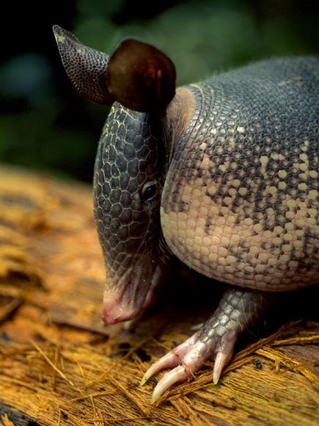

An armadillo roots around the forest floor in search of food. Armadillos have poor eyesight but a keen sense of smell and long claws for digging.
Of the 20 varieties of armadillo, all but one live in Latin America. The familiar nine-banded armadillo is the only species that includes the United States in its range.
Armadillo is a Spanish word meaning “little armoured one” and refers to the bony plates that cover the back, head, legs, and tail of most of these odd looking creatures. Armadillos are the only living mammals that wear such shells.
Closely related to anteaters and sloths, armadillos generally have a pointy or shovel-shaped snout and small eyes.
They vary widely in size and colour, from the 6-inch-long (15-centimeter-long), salmon-colour pink fairy armadillo to the 5-foot-long (1.5-meter-long), dark-brown giant armadillos. Others have black, red, grey, or yellowish colouring.
Contrary to popular belief, not all armadillos are able to encase themselves in their shells. In fact, only the three-banded armadillo can, curling its head and back feet and contorting its shell into a hard ball that confounds would-be predators.
Armadillos live in temperate and warm habitats, including rain forests, grasslands, and semi-deserts. Because of their low metabolic rate and lack of fat stores, cold is their enemy, and spates of intemperate weather can wipe out whole populations.
Most species dig burrows and sleep prolifically, up to 16 hours per day, foraging in the early morning and evening for beetles, ants, termites, and other insects. They have very poor eyesight, and utilize their keen sense of smell to hunt. Strong legs and huge front claws are used for digging, and long, sticky tongues for extracting ants and termites from their tunnels. In addition to bugs, armadillos eat small vertebrates, plants, and some fruit, as well as the occasional carrion meal.
Population numbers of nearly all species are threatened by habitat loss and over-hunting. Many cultures in the Americas consume armadillo flesh, which is said to resemble pork in its flavour and texture. Currently, only the nine-band population is expanding, and some species, including the pink fairy, are threatened.

The Puff Adder – Ifwafwa
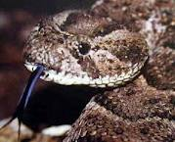

IFWAFWA is named after the Puff Adder snake, which, he says, is slow and heavy, but fast to strike.

Here are some more facts about the Puff Adder.

About Puff Adder
The Puff Adder lives in a lot of different habitats such as woodlands and the semi-desert. They feed on rats, mice and small mammals. This snake is one of Africa's most dangerous because they wait in the road at night until someone steps on it and then they strike.
The Puff Adder gets its name from the way it puffs up when threatened.

Life Cycle of the Tapeworm

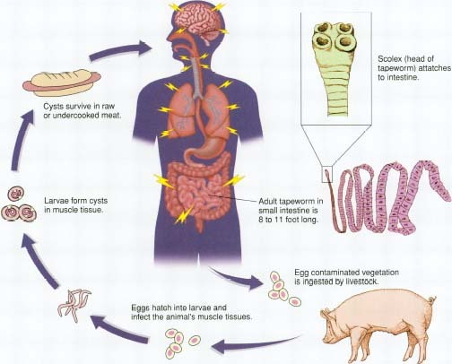

Brief Definition of AIDS

AIDS is caused by the HIV virus, and it makes people sick by killing the cells that defend the body from infection. When the virus kills too many cells, the person has AIDS.
People get HIV when the fluids in their body mix with the fluids of infected people.

Hookworm Images

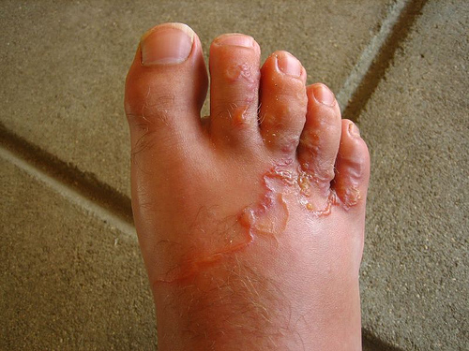

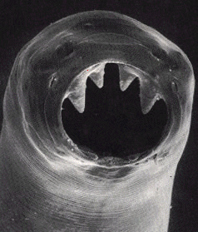

See Microbe World - http://www.microbeworld.org/index.php?option=com_content&view=article&id=867:twip-22-hookworm&catid=99:this-week-in-parasitism&Itemid=259

The Baobab Tree

Baobab trees are native to Africa and they are also found in Australia. They can grow to be 80 feet (24 meters) tall; the biggest is 155 feet (47 meters) round. The leaves of the Baobab are edible and are eaten as a vegetable and in Australia they are used as medicine. The Baobab fruit is used in different ways too. It is eaten raw, dried and squeezed as a juice. The seeds are pounded into oil. And the shells of the fruit are burned for heat. The Baobab is deciduous meaning it sheds its leaves once a year. But what makes the baobab tree really neat is how it has adapted to survive. This enormous tree lives in places that have little or no rain for several months in a row. How does such a big tree survive without water? Baobabs can store up to 120,000 litres (32,000 gallons) of water in their swollen trunks. They use the water a little at a time until the next rains come.

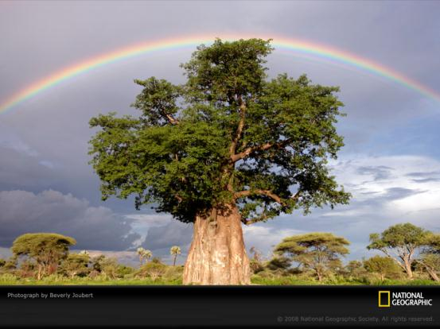

Some Useful Words in chiBemba

ee - yes
awe - no
ulishani – hello
shalenipo - goodbye
Ishina lyandi ni... - My name is...
umuntu – person
umunandi – friend
umwana - child
chiBemba - the Bemba language

Cloze Procedure 1

Ifwafwa
I visit all the houses in this town. The big ones with trees and swimming pools and the small ones that are sometimes blown away in the storms. I am welcome in all of them because I take the snakes with me when I leave. Nobody turns me away. Nobody asks me questions about how I do it. They are grateful and my gift is growing. My grandmother told me that a gift does not stay the same; you must use it well. You must practise and then you will get better. If you do not use it, you will find one day that it will turn against you. I did not want that to happen. So I carried on practising. She was right. There is no snake any more that can resist me. Not even the Gabon viper.

I never used to see it around town; it stayed near the trees in the land that lies low. Not like here in Lusaka, where we sit so high above the sea that I think it is easy for Lesa to watch over us. But now the viper comes here. Everyone is afraid of it, the snake with the little horns on its nose. The snake with the bags of poison that never run out. The snake that could bite many people and kill every one of them. But it doesn’t bite unless it has no choice. The people fear it because of these bags, but it is a quiet, kind snake. The easiest for me to catch. It never runs from me.

Cloze Procedure 2

Ifwafwa
I visit all the _____in this town. The big ______with trees and swimming _______ and the small ones that are sometimes _______ away in the storms. I am _________ in all of them because I take the ________ with me when I leave. Nobody ______ me away. Nobody asks me __________ about how I do it. They are grateful and my _____ is growing. My grandmother _____ me that a gift _____ not stay the same; ______ must use it well. ______ must practise and then _____ will get better. If you do not ____ it, you will find _____ day that it will turn against you. I did not want that to happen. So I _________ on practising. She was right. There is no snake any more that can ______ me. Not even the Gabon ______ .

I never used to see it around_____ ; it stayed near the trees in the land that lies low. Not like here in Lusaka, where we sit so high above the ____ that I think it is easy for Lesa to watch over us. But now the viper comes here. Everyone is ________ of it, the snake with the little horns on its nose. The snake with the bags of ________ that never run out. The snake that could bite many people and _____ every one of them. But it doesn’t ____ unless it has no choice. The people fear it because of these bags, but it is a quiet, ____snake. The easiest for me to catch. It never ____ from me.

The Bird and the Badger

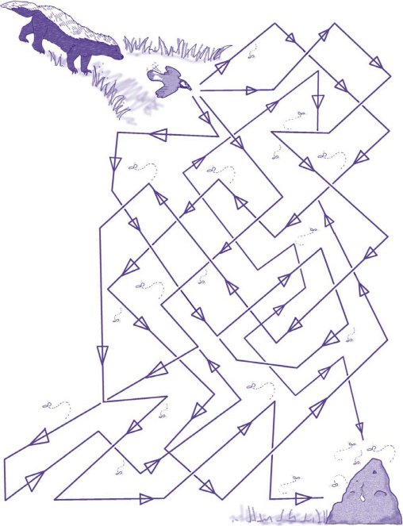www.netplaces.com/...mazes/.../honey-guide-bird-and-honey-badger.
This bird and badger have a very good relationship.
The honey guide bird will make a lot of noise and flick his tail up and down to get the attention of the
Honey badger. Then, the bird will lead the badger to a bee's nest. The big, strong badger will break open the
nest and eat the honey. Meanwhile, the bird gets to eat the yummy larvae of the bees and the wax!
Make sure the honey guide bird and the honey badger follow the correct path to the bee's nest.
Say No to Child Marriage - Images
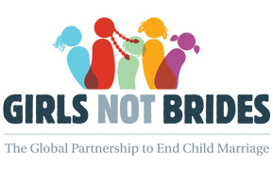

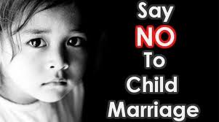

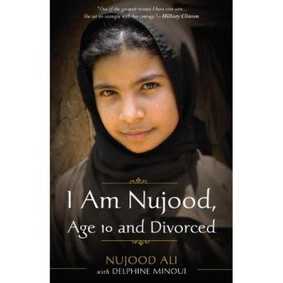

Websites:
UNICEF
Girls Not Brides Campaign

Bemba Bingo

Madillo loves numbers and can count to 999,999 in Japanese. In Bemba (Chibemba) the numbers from 1 to 10 are:
-` | 1 | 2 | 3 | 4 | 5 | 6 | 7 | 8 | 9 | 10
Bemba: | mo | bili | tatu | ne | sano | mutanda | chine lubali | chine konse konse | pabula | ikumi

Mini Bingo
Make a bingo card using 5 numbers. Your teacher will call out the numbers above at random. See who is the first to have all their number called.

Basic Vocabulary and Phrases
- ee - yes
- awe - no
- ulishani - hello
- shalenipo - goodbye
- Ishina lyandi ni... - My name is...
- umuntu - person
- umunandi - friend
- umwana - child
- chiBemba - the Bemba language
- na - and, with
- nga - like, as
- suma (adj.) - good
- onse (adj.) - al

Winifred’s Chapter

d | A | E | S | t | h | g | i | a | r | t | s | e | U | D
N | i | t | n | e | b | m | a | n | C | D | N | s | E | G
A | E | s | E | O | L | O | O | F | E | V | C | u | G | S
M | O | F | a | E | A | O | I | E | I | O | E | o | E | Y
H | N | E | N | p | t | A | N | O | A | N | N | h | Y | A
I | I | S | D | a | p | O | R | T | V | S | R | T | S | O
L | A | E | v | R | M | e | u | n | c | l | e | S | L | O
T | Y | e | B | N | T | E | a | A | I | d | y | A | Y | E
E | r | Y | L | I | A | O | M | r | e | O | e | F | C | S
n | S | B | F | T | E | A | O | r | E | N | s | E | I | I
O | E | Y | H | H | S | L | f | h | O | R | I | R | T | T
F | G | A | E | O | E | i | R | e | D | Y | C | T | O | T
I | E | G | A | I | n | S | R | a | H | S | T | U | L | A
C | A | F | H | i | N | I | E | r | D | L | A | E | T | E
R | E | E | W | F | E | R | L | G | d | e | a | d | S | B

CLOZE Passage
My ma doesn't walk _______________ any more. Her back is _______ and her _______ look at the floor. When she talks to me it's as if she doesn't want me to _______. It's because of what's happening, I know that. She doesn't know how to tell my _________ to take this thing away, to chase the old _____ out of the _________. To send him back to the ___________ so he can drink until he is _______. That is what I want: I want him to die so he can't look at me anymore. I want him to _________________ so I can be _______________ again. So I can go to school without this big weight dragging behind me.
Words Used
disappear, straight, Winifred, tavern, uncle, house, bent, eyes, hear, dead, man,

Last Will and Testament
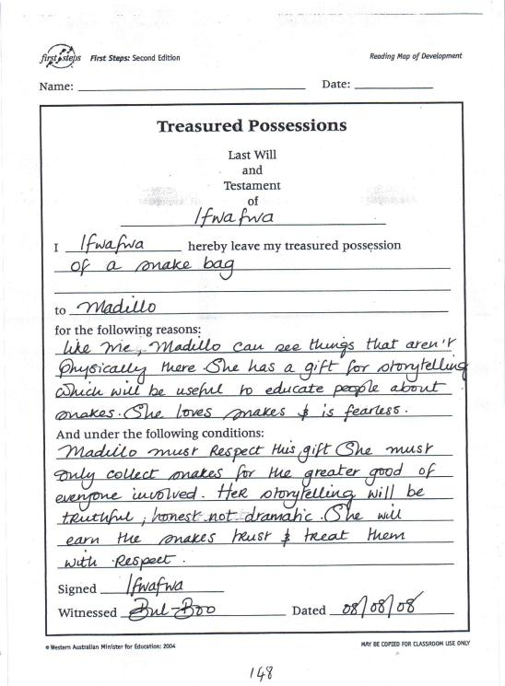

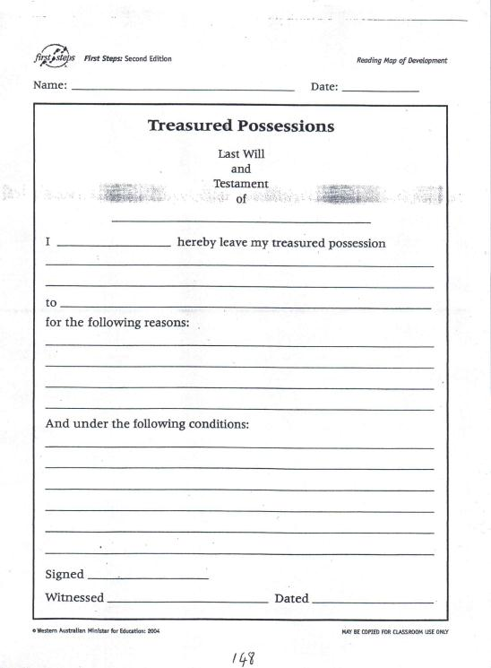

Madillo’s School Report
This could be used with either Bul-Boo, Madillo, Winifred, Fred or David as the characters we have been introduced to at school. Useful and fun exercise in assessing their understanding of the characters.
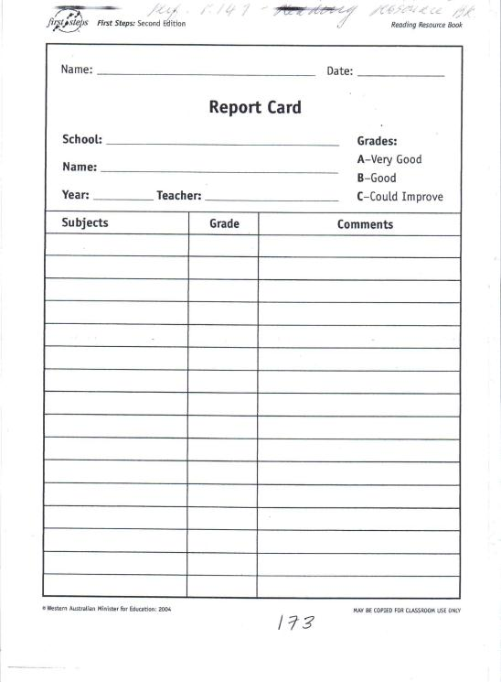

Character Exercises

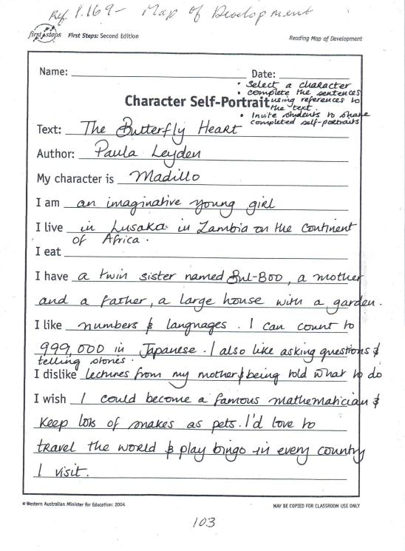

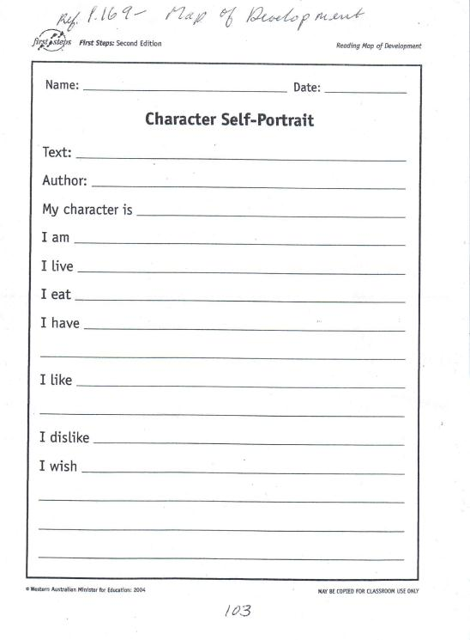

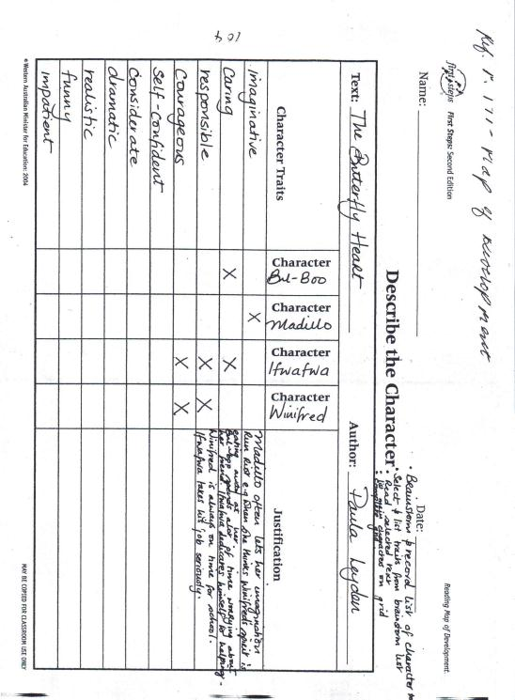

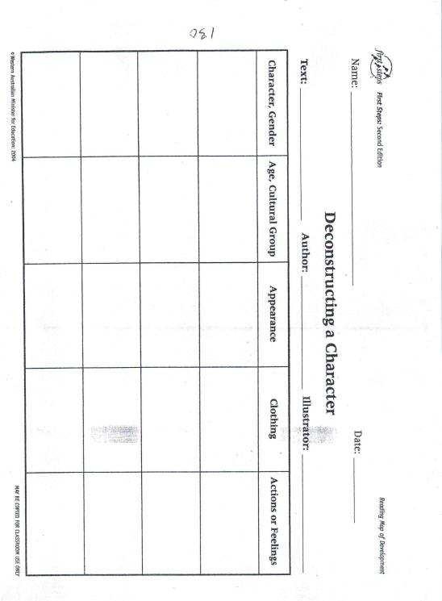

Things you didn’t know about Paula Leyden

- I was born all tangled up in a knot - my poor mum!
- I hypnotised myself to stop eating chocolate - otherwise I would eat two or three bars a day.
- I set off the fire alarm at boarding school to get out of a Double Physics class. I am not proud of that and wish I had paid more attention to Physics.
- I am allergic to cats and horses - and breed horses.
- At boarding school I sat for eight hours in front of a plate of liver refusing to eat it. I was eleven. The nuns eventually gave up and sent me to bed. The thought of eating animal innards makes me feel ill.
- I hate cruelty and smugness.
- The furthest I have sleepwalked is about half a mile.
- I can neither draw nor sing, but I can do other things so don't mind too much.
- I have been told I am very stubborn, but refuse to believe it.
- I am extremely content in my life, but wish we lived in a kinder world.
Paula and Grouse!

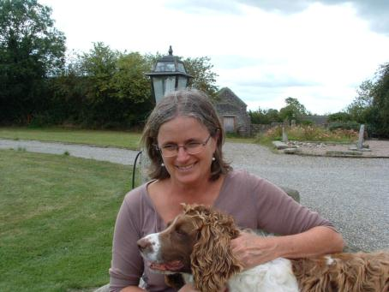
Sentence Search
Finish the following sentences - Chapter 1 Bul-Boo

Page When the bell rang she
Page There is nothing shadow-like
Page She is short and neat
Page Today Winifred didn’t tell a story;
Page I wondered if I’d said something
Finish the following sentences - Chapter 2 Ifwafwa

Page It’s a nickname, she said,
Page She has a laugh
Page As it travels down her long body,

Finish the following sentences - Chapter 3 Bul-Boo

Page Where her house is,
Page She once said to us
Page Me, Sister Leonisa,
Page But quickly it transforms
Page It creeps up
Page When it is out
Finish the following sentences - Chapter 4 Ifwafwa

Page She could look
Page Those people would leave
Page She was my
Page But it was not my mother
Page My grandmother would have been
Finish the following sentences - Chapter 5 Bul-Boo

Page He had promised to
Page Fred says that she is
Page You cannot even
Page For him, it’s not an insult
Page It flies slowly
Page I will have to try very hard
Finish the following sentences - Chapter 6 Ifwafwa

Page When I tell stories, my mother
Page But it all stopped
Page He said he would
Page She helped me home

Finish the following sentences - Chapter 7 Bul-Boo

Page But I am glad
Page “Well, she doesn’t put her
Page “Probably
Page “She just sits
Page Evil spirits aren’t
Finish the following sentences - Chapter 8 Bul-Boo

Page It’s quite something to watch
Page “Once upon a time four beautiful girls
Page The tree heard
Page “This suited the tree
Page It was from that day
Page She is one of the best at
Finish the following sentences - Chapter 9 Bul-Boo

Page She was at school, but
Page So I know more than her
Page But apart from Mum’s stubborn
Page They literally worm their way in
Page Dad left Zambia
Page Dad says that people in Africa with AIDS
Finish the following sentences - Chapter 10 Ifwafwa

Page My mother told me that he
Page The best we could hope for
Page I never saw
Page Perhaps, for him,
Page The only time anyone believes is
Finish the following sentences - Chapter 11 Bul-Boo

Page I spoke to her at break
Page She almost looked
Page She is very small
Page I took the bet
Page Fred says that she lives with them because
Page “I have sometimes seen Winifred walking
Finish the following sentences - Chapter 12 Bul-Boo

Page There are some things that are
Page He rubbed his hands together
Page I walked slowly back to class
Page I’m going to be his wife
Page “He’s a policeman

Title: _______________________ Author: ________________
Date started: ____________ Date finished: ____________

What was the book about?
_________________________________________________________________________________________________________________________________________________________________________________________________________________________________________________________________________
What did you like about the book?
_________________________________________________________________________________________________________________________________________________________________________________________________________________________________________________________________________
Were there any parts you didn’t like? Discuss.
_________________________________________________________________________________________________________________________________________________________________________________________________________________________________________________________________________

What was your favourite part of the book?
_________________________________________________________________________________________________________________________________________________________________________________________________________________________________________________________________________
Would you recommend this book to a friend?

YES NO
How many stars would you give this book? Colour the stars.
(5 – Excellent, 1 – Poor)

Draw a picture to show your favourite part of the book.

Colour the words that describe this book.
Funny

Sad

Adventurous
Wonderful
Terrific
Bogus
Amazing
Fantastic
Exciting
Spooky
Boring
Scary
Silly
Interesting
Crazy
This book was (shade in the words you agree with)
Entertaining
Creepy
Incredible

Colourful

Can you think of any other words to describe this book? Write them down here:

________________________________________________________________________________________________________________________________________________________________________________________________________________________________________________________

