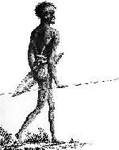

- Aboriginal men hunted kangaroos, wallabies, possums, ducks, swans and parrots for food.
- The men used spears and boomerangs made from stone, wood or bone to kill these animals.
- The Aborigines used the different foot tracks of animals to find their prey.
- Large animals were killed using spears or clubs. Smaller animals were killed using nets and pits in the ground.
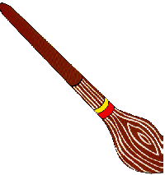
- They used some clever tricks to get their prey. They covered themselves in mud as camouflage and to hide their smell. They attracted emus, which are curious animals, by copying their movements using a stick and some feathers!
- A nulla-nulla was a kind of club used
for hunting. It had a head made of
wood or stone and this was attached to
the handle using string, hair and beeswax.

- Fishing was another source of food. The fish were speared or caught in nets. Sometimes they poisoned the water to kill the fish.
- They made fishing lines from animal or human hair. Fishing hooks were made from the bones of animals.

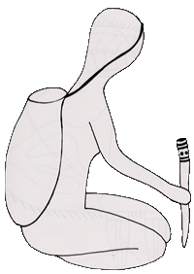
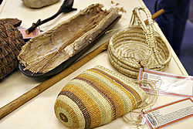

Woman’s Basket and digging stick.

- Aboriginal women, often carrying babies on their backs, were the main food gatherers. They would set out most days searching for and collecting berries, nuts, plants, fruit, eggs and other food.
- They used digging sticks to look for roots underground.
- Any food they found went into a small bag called a dilly bag.
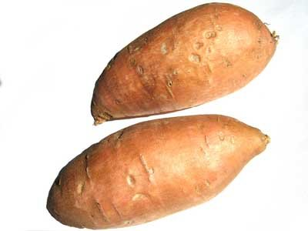
- One food the women found using digging sticks, were yams. These could be eaten raw or
cooked in the ashes of a fire.
- The women’s skill in finding food often
kept the group alive.
- They prepared and cooked the food on a campfire or earth oven.
- Children learned to hunt and gather food at a very young age from helping and watching their mothers.

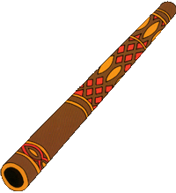

- The aborigines loved to dance, sing and make musical sounds around the campfire.
- The didgeridoo is the best known of their musical instruments.
- Didgeridoos have an average length of 1.3 metres.
- The didgeridoo is a drone instrument which means it can only play one note.
- It was originally played only to accompany special ceremonies but now it is played for enjoyment too.
- Art was an important part of life.
- Bodies were painted for ceremonies with special symbols.
- Designs were painted on the walls of rock shelters
- Bark painting is probably the most well known Aboriginal art form. Colours were made from rocks, clay and charcoal so red, brown, black and white were the most common colours.
- The paintings told stories and were a record of daily life.

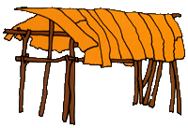
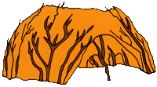

- The aborigines were nomads or wanderers.
- They moved from place to place in search of food as the seasons changed.
- They did not settle in one place and farm the land or create towns or villages.
- As a result of this, an aboriginal home could be many things
  - A shady place under a tree
  - A cave to shelter from the sun or rain
  - Or a bigger stronger shelter that they used again whenever they moved
- Most homes were only used for a month at most.
- Homes were called Mia-Mias or Gunyas by the Aborigines.
- The Aborigines made their shelters out of bark, branches, leaves and grass.
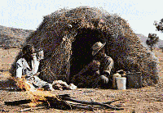

- When an aboriginal child was born, they began to learn how to stay alive and the rules of their tribe.
- Shortly after he could walk, aboriginal boys began to handle small spears, follow their fathers and the other men, watching while they fished and made tools.
- Little girls followed their mothers, learning how to cook, gather food and take care of the younger children.
- Teenage aboriginal boys were sent on a Walkabout when they were old enough. They had to walk into the outback and fend for themselves for about 6 months. They would follow the paths taken by their spiritual ancestors from the Dreamtime.
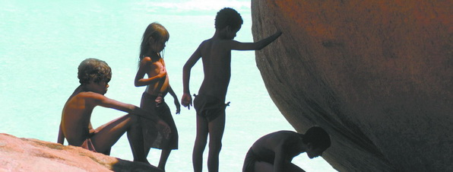
- The Aborigines believed that when the boy re turned he would then be an adult.

- The Aborigine’s way of life was based on their Dreamtime beliefs.
- They believed the world began during the Dreamtime. In Dreamtime their ancestors were sent to shape the world. They made the mountains, trees and rivers and taught people how to survive.
- Many aborigines believe that the Rainbow Serpent is the most important part of Dreamtime.
- They believed the snake had the power to create humans and that humans are its decedents.
- The Rainbow serpent is also believed to provide water and food for the people as well as sending floods and drought when it is angry.
- The Aborigines love the land they live on because they believe their ancestors made the land for them.
- They also believe their spirits still live in the land.
- The stories help explain how the land, animals and plants were created.
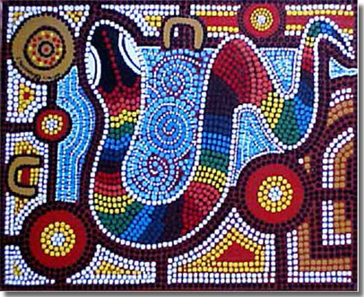
- They also were used to teach aboriginal children how to live their lives.

Aboriginal History
Read each fact file carefully and answer the questions below with your group.
Station One: Hunting and Fishing
How did the aborigines find their prey?
___________________________________________________
What is a nulla nulla?
___________________________________________________
Describe one trick they used to get their prey.
________________________________________________________________________________________________________
Station Two: Aboriginal Women
List examples of the food the women gathered.
____________________________________________________
What did they use digging sticks for?
____________________________________________________
Why were the women so important to the tribe?
____________________________________________________
Station Three: Music and Art
What is the average length of a didgeridoo?
____________________________________________________
What are the main colours seen in aboriginal art?
____________________________________________________
What were the functions of the paintings?
____________________________________________________
Station Four: Homes
Why did the aborigines move from place to place?
____________________________________________________
What are the two names for aboriginal homes?
____________________________________________________
What did the aborigines make their homes from?
____________________________________________________
Station Five: Childhood
What did aboriginal boys spend their time doing?
____________________________________________________
What did aboriginal girls spend their time doing?
____________________________________________________
Why do you think the young boys were send into the outback on their own for Walkabout?
____________________________________________________
Station Six: Dreamtime
What do the aborigines believe happened in the Dreamtime?
____________________________________________________
What powers had the Rainbow Serpent? (3!)
____________________________________________________
____________________________________________________
Why do the aborigines love and respect their land so much?
____________________________________________________
____________________________________________________

