WINTER OLYMPICS

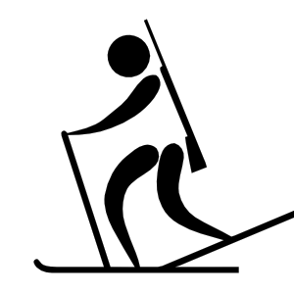
Biathalon - Each group has 2 carpet squares and 1 bean bag. Students use the carpet squares for skiis. They travel across the gym, holding the bean bag, to the cone and throw the bean bag at the target on the wall. The student retrieves the bean bag and returns to the line. 1 point for every bean bag that hits the target.

2-Person Bobsled - The first student sits on the floor. The second student sits behind the first one & hooks his/her arms around the waist of the first. Then they travel across the gym and back using their bums & legs to propel them. 1 point for every 2-person team to return in the allocated time.

The Luge - The first student lies on their back on a sack on the floor. The second student gently pulls the person on the sack around the cone and back. 1 point for every pair who return to start line!

Curling – Each student slides a bean bag as close to the target as possible. 1 point for every bag that reaches the inner ring.

Hockey Dribble - Using a hockey stick each student dribbles a beanbag around the cone on the other side of the gym and back.

Ski Jump – Each student must jump over a measured distance and land on the blue mat. 1 point for every two-footed land on the mat. The distance can be changed after each member of team has had a turn.

How to play Winter Olympics:
Pupils create teams of 3 or 4. Each team choose a country to represent. Each team design their countries flag and learn the National Anthem of their country. This will be for the Awards Ceremony!
After explaining each activity, teams line up at each Game. When the whistle blows, the team tries to score as many points as possible at their station within 1 minute! Pupils score their individual results on their personal Score chart. Then each team correlate their scores on their Team chart.
At the end of the Olympic Games, the teacher announces the individual winners of each event! The team of the first place winner must sing the national anthem at the ‘medal’ ceremony. Each student receives a cardboard medal (gold, silver, bronze) to attach to the giant scoreboard.
Then the teacher announces the team winners of each event. Each member of the team receives a medal (gold, silver, bronze) to attach to the giant scoreboard. Again the team who come first place must sing the national anthem at the ‘medal’ ceremony.
Finally, the class convert the scores to points allowing gold=3, silver=2 & bronze=1. Which team will win Winter Olympics?

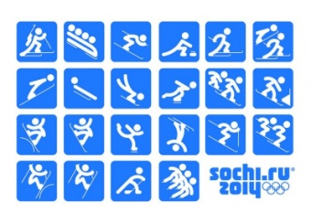
WINTER OLYMPICS
STUDENT INDIVIDUAL SCORE CARD

Name:
Event | Score
Biathlon
Curling
Ski Jump
Hockey Dribble

WINTER OLYMPICS
STUDENT INDIVIDUAL SCORE CARD

Name:
Event | Score
Biathlon
Curling
Ski Jump
Hockey Dribble

WINTER OLYMPICS
TEAM SCORE CARD

Country:
Event | Score
Biathlon
Curling
Ski Jump
Hockey Dribble
The Luge
2 Person Bobsled

WINTER OLYMPICS
TEAM SCORE CARD

Country:
Event | Score
Biathlon
Curling
Ski Jump
Hockey Dribble
The Luge
2 Person Bobsled

