6th class Design & Make your own Bridge

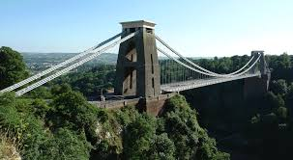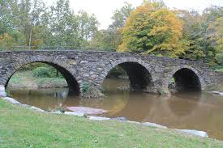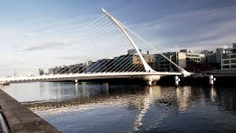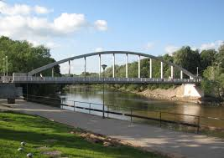

Objective: Design & make a bridge based on pupil’s personal creativity and research of designs of famous bridges.

Strand Units/Skills:
This project covers the following;
- Science: Design & make/ Forces/ Materials/ Science & the Environment? Investigating/ Experimenting
- Maths: Measurement/ Shape & Space
- Visual Art: Construction/ Fabric & Fibre/ Drawing
- English: Oral Language/ Writing/ Creativity
- ICT: Research, site search & filter information/ Summarise and synopsise/ Digital imagery access/ Word processing
- Geography: Human Environments/ Environmental Awareness
- 21st century skills: Problem-solving/ creativity/ innovation

Timeframe:
- You have 7 days to complete this project starting on Monday 10th February
- You must complete a 5 day diary to illustrate that you actually worked on your project for 5 of these days.

Background:
You are to design a bridge. Begin by considering current bridges in Ireland and abroad. Examine the visual design as well as the functionality of each of these bridges. Allow your imagination to open up to what changes or advancements you would make to any of these bridges.

Consider the following;
- Architecture & design of bridge.
- Function of the bridge – what is the purpose?
- Suitable Materials for both your design and to meet the criteria of weight, length & travel purposes.
- Marking System & timeframe – plan accordingly and remember to cover all criteria.
Criteria: You need to;
- Design & make a bridge which must be more than 30cm long. It must be able to stand alone. (5 marks)
- It must be able to hold a weight of 500g. (half a bag of sugar) (10 marks)
- It must be able to have a car travel along it. (5 marks)
- You have to be able to explain any changes that you made. (For example, the glue wouldn’t stick the two things together so I had to use string.) (10 marks)
- You have to say where you got your inspiration from & why e.g. the Ha’penny bridge or the Golden Gate bridge etc. (5 marks)
- You have to be able to describe your bridge e.g. an arch bridge, a suspension bridge or perhaps a combination of two bridges. (10 marks)
- Produce two designs that include diagrams, labels & explanation. The first plan must be presented by Wednesday 12th Feb. showing your plan before you begin you project. The second plan must illustrate changes that were made and must be presented by Monday 17th Feb. (30 marks)
- Keep a 5 day diary, recording the work you have done over at least 5 days. Use template provided. (15 marks)
- Decoration & visual presentation will get extra credit. (10 marks)
- Finally name your bridge. Create a small card illustrating the Name of your bridge and the name of the engineer. This will accompany your bridge on display.
- Closing date for project is Monday 17th Feb. Late submissions of any or all parts of the project are subject to a loss of 10 marks
- Have fun and don’t drive everyone at home mad!

Materials can include;
Buttons Tin cans String Shoe boxes
Cotton swabs Paint Lollipop sticks Marla
Bamboo sticks Matchsticks Cardboard Elastic bands
Wood Glue Plastic String
Milk cartons Duck tape / Cello tape Pringle boxes Nails
Ribbons Screws Bottles Thumb tacks
Straws Blu-tack Bubble wrap Tinfoil

PARENTS ROLE

*Parents, this project intends to develop independent study essential to second level. Children can be assisted and guided but the design, drawings, records and bridge should be produced by the child themselves. Remind your child to keep it simple!! You can help by bringing them to the library, assisting with research online, reviewing spellings & punctuation, redrafting, cutting materials or using dangerous tools, etc. And finally encouraging & praising good efforts.

Please do not, under any circumstances, do the work for your child and ask them to pass it off as their own. This will not teach them the importance and value of their own work, no matter what level that may be!
Design & Make your own Bridge
Daily Diary/Record of Work completed

Name: ___________________

Day 1
__________________________________________________________________________________________________________________________________________________________________________________________________________________________________________________________________________________________________________________________________________________________________________________________________________________________

Day 2
__________________________________________________________________________________________________________________________________________________________________________________________________________________________________________________________________________________________________________________________________________________________________________________________________________________________

Day 3
__________________________________________________________________________________________________________________________________________________________________________________________________________________________________________________________________________________________________________________________________________________________________________________________________________________________

Day 4 __________________________________________________________________________________________________________________________________________________________________________________________________________________________________________________________________________________________________________________________________________________________________________________________________________________________

Day 5 __________________________________________________________________________________________________________________________________________________________________________________________________________________________________________________________________________________________________________________________________________________________________________________________________________________________

