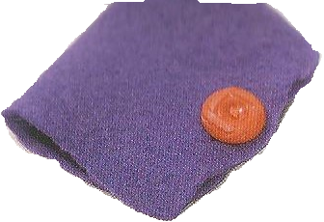
Needles Book

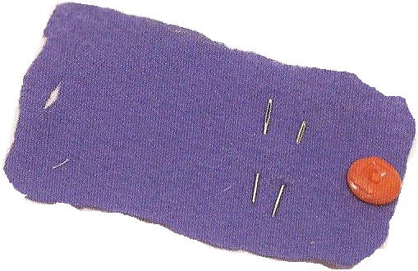
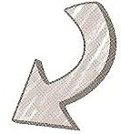
Needed:
*Pattern *Scissor *Thread
*Felt *Button
*Chalk *Thread

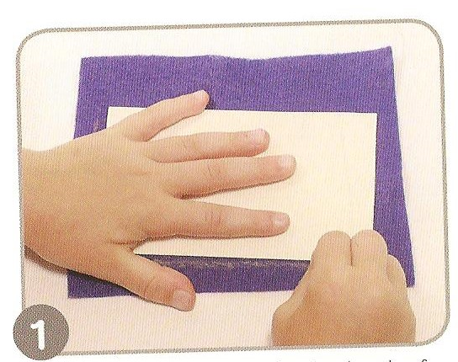
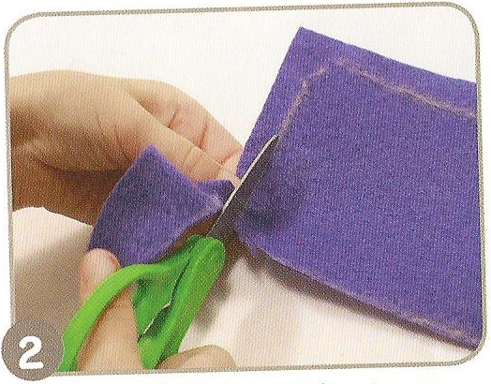

Using the pattern ‘Needle Book’ draw Cut out the felt on the chalk line.
around the pattern with chalk.

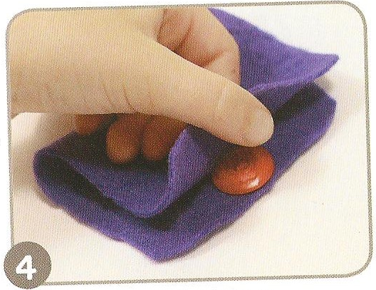
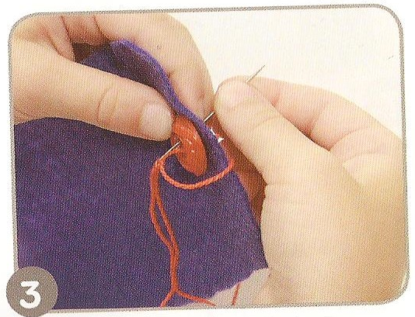

Now to attach the button - sew the Fold the fabric over, covering the button.
button to one side of the felt.

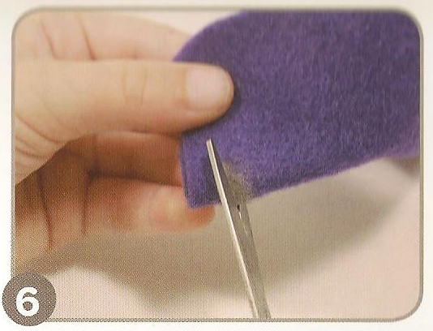
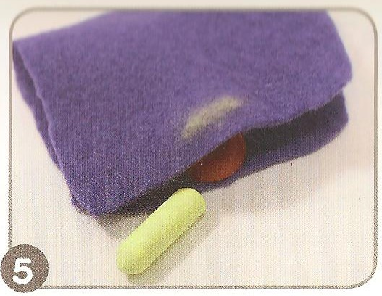

Mark where the button is with chalk. Fold the felt and cut where the chalk is to
make a hole.

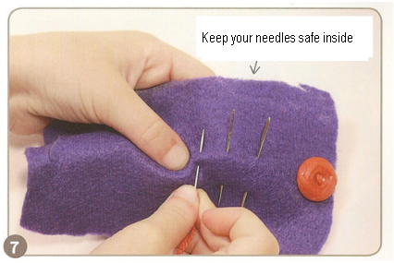
Now put your needles in, through the felt.
Now your needle will be kept safe there for you!

Put your stamp on it -
*make a book out of it by putting ‘pages’ in (2 or more books attached)
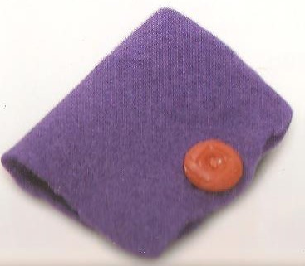
*Put some art on it – embroidery or special paint.

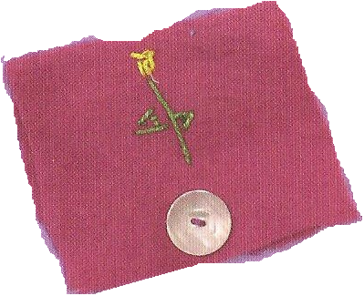

Patrún

Needle Book

