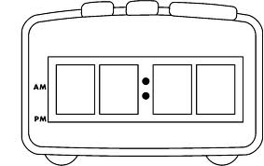  O’Clock | The Digital Clock uses Numbers to tell the time.  Always use Four Digits on your digital clock to make sure it’s correct.  The separator between the hours and minutes is called a Colon, and is made of Two Dots.  Always put the Hour first and the Minutes second. | Quarter Past
Half Past |  | Quarter to

5 past | 25 past | 20 to
10 past | It is easier to read the time on a digital clock when it is Past the hour.  When reading the time To the hour, e.g. for 7:50, either say seven fifty, or ten to eight.  To work out how long is left To the hour, take the number from 60. | 10 to
20 past | 25 to | 5 to

3 minutes past | 27 minutes past | 9 minutes to
8 minutes past | It is easier to read the time on a digital clock when it is Past the hour.  When reading the time To the hour, e.g. for 7:34, either say seven thirty-four, or twenty-six minutes to eight.  To work out how long is left To the hour, Round to the nearest 5 and then take the number from 60. | 13 minutes to
19 minutes past | 2 minutes to | 26 minutes to

