Archaeology

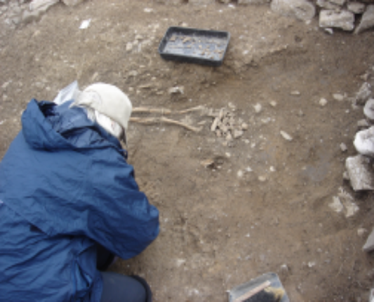Archaeology is the study of artefacts to try and find out more about past life. Archaeologists are the people who carry out this work. An archaeologists’ work is mainly conducted outdoors, and excavation (digging) is the method they use to explore what lies beneath the surface of the earth. Historical research is also important when deciding where to excavate, and when trying to interpret what has been found.

The finds on a site are not always necessarily of great value, but can never the less tell us a lot about what people have done in the past. Archaeologists look for things people have used and then thrown away or lost. Even old rubbish can provide important evidence of what life was like for people long ago. Similarly, if someone was to look through our rubbish bins of today, in 2000 years time, they could tell to some degree what sort of lives we were living in 2007.

Archaeological evidence is found in layers, which have been built up over time. Each layer in the ground most likely represents 100s of years of human activity. Generally the deeper you dig, the older the layers and artefacts are. The excavation, or digging, of a site involves the removal of layers (soil, rubble etc.) and features (pits, walls, burials etc.) found in those layers.

Collectively these layers are called contexts. Contexts are removed in the reverse order of their deposition. This means that when you start digging, you are seeing the most modern material, and as you keep digging, you come across the most ancient material. Archaeologists usually keep digging until they hit natural sub-soil, or undisturbed bedrock.

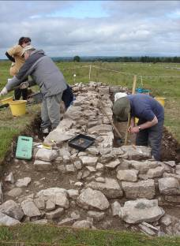
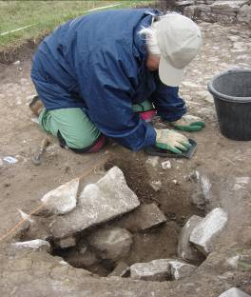

A pit being excavated A wall being excavated

Any artefacts discovered on the way down are removed for study. It is also useful to take some samples of the soil that is being dug out, because not everything is visible to the human eye. Study of this soil under microscopes in a laboratory can reveal important finds such as fish bones and seeds from crops (e.g. wheat and barley). Therefore we can tell what type of diet our ancestors lived on thousands of years ago!

The tools that are used on an excavation range from shovels to trowels, wheelbarrows to buckets, and from spades to very small brushes. An archaeologist is always very neat and organised in their work; because although excavation is carried out to learn more about the past, it means that the archaeology and layers in the ground are being destroyed in the process of digging. In other words, archaeologists only get one chance to dig a site properly. Therefore excavation is often referred to as ‘constructive destruction’. Careful planning and recording is always carried out before, during, and after excavation of an area. Photography, drawing, and digital scanning are all methods that are used to record the layers, and artefacts that are found.

Modern technology is making life easier for archaeologists, for example, rather than spending days drawing features as they are uncovered, a ‘laser scanner’ can now be used. This piece of equipment sends beams out to ‘scan’ a piece of terrain (ground), and sends the information back to a computer. The computer creates an image, which looks just like a photograph. However, this image provides a lot more information than a photograph can. For example, the distance between artefacts, and the height they are sitting at above sea level can clearly be identified.

Once the site has been excavated and recorded, the site is filled in with soil again, and the information and artefacts are taken to the office of an archaeologist. The information is processed, and a report is written to inform the public about what has just been discovered and learnt about past life. The artefacts are usually washed and cleaned, and receive conservation or preservation treatment if necessary. They are then given to the national museum (such as the National Museum of Ireland), or the local museum (such as the Sligo County Museum) for storage, or to go on display.
Questions

1 What is archaeology?

2 How do archaeologists explore what lies beneath the surface of the earth?

3 What do archaeologists look out for when they excavate?

4 Why might it be useful to take soil samples when excavating an archaeological site?

5 Name four tools used by archaeologists.

6 What happens to artefacts once they are taken away from an archaeological site, and where do they end up?

7 If you had a chance to work as an archaeologist what people would you like to learn more about?

